

Lyng Primary School Knowledge Organiser

Art

Victorians- How does Lowry’s art depict urban Britain?

Spring

Year 6

Topic: Art

|  |  |
| --- | --- |
| Vocabulary | |
| **Spelling** | **defintion** |
| architecture | The art of designing or constructing buildings. |
| horizon line | A line at eye-level where the sky meets the land. |
| industrial | Designed or suitable for use in industry (factories). |
| landscape | All the visible features of an area of land |
| urban | In or related to a town or city. |
| vanishing point | The point on the picture which shows the furthest point that the artist can see. |

**Background information for parents and teachers**Children will develop their sketching techniques. They will experiment with depth and one point perspective. Children will show a good understanding of artistic styles in describing and explaining style choices of significant artists (L.S Lowry). Children will also show how the work of those studied was influential in both society and to other artists. They will consider how Lowry’s work reflects the life of working class Victorian Society.

|  |
| --- |
| Skills and techniques |
| Analyse to understand context   * Sketch buildings in perspective. * Sketch lightly before painting. * Sketch movement in people and animals. * Comment on our work and the work of others positively. * Use sketchbooks to develop ideas and record ideas as we learn * Reflect Victorian lower classes in my piece. * Use a colour palette based on Lowry’s. |

**Spring**

A Victorian Street using matchstick men and one-point perspective.

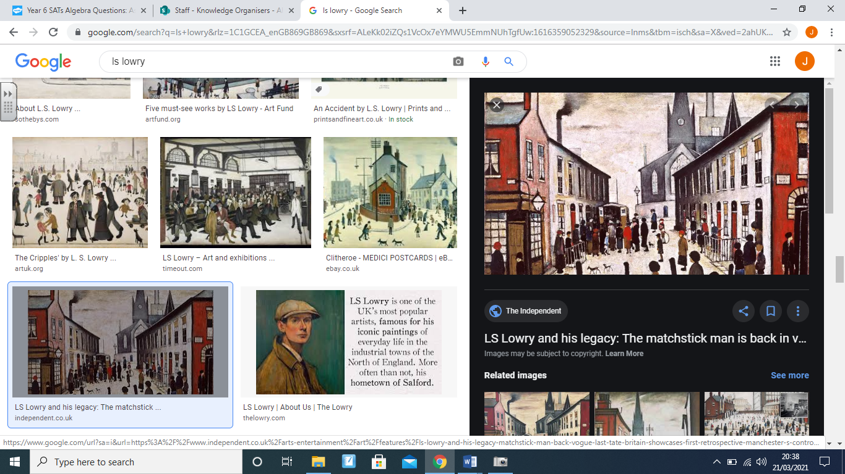

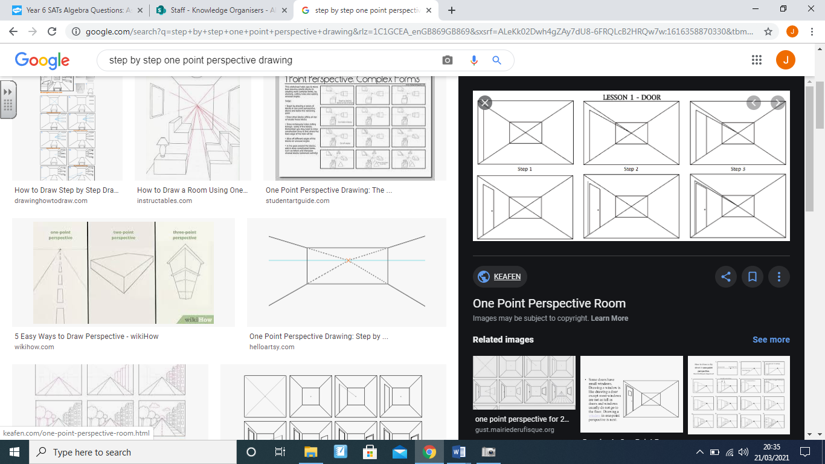

How can we create one-point perspective?

Using step-by-step approach with:

* Vanishing point
* Horizon Line
* Perspective diagonals.
* Accurate drawing of vertical lines.
* Accurate drawing of horizontal lines.



Agreed outcome:

A Victorian Street using matchstick men and one-point perspective.